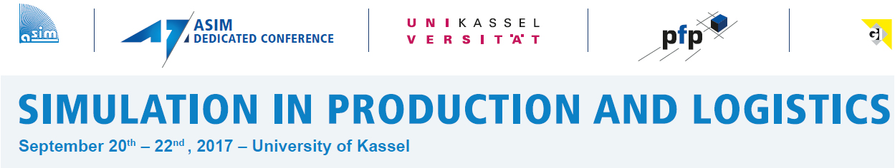

Universität Kassel – Fachbereich Maschinenbau

Institut für Produktion und Logistik

Produktionsorganisation und Fabrikplanung
Dipl.-Wirtsch.-Ing., M. Sc. Tim Peter
Kurt-Wolters-Straße 3
34125 Kassel - GERMANY

FAX: +49 561 804-1852

REGISTRATION:

Herewith, I register for participating in the 17th ASIM Dedicated Conference "Simulation in Production und Logistics" from 20th to 22nd September 2017 in Kassel:

name, first name
company / institute
street, no.
ZIP code, city, country
phone / fax
e-mail

Please, check the applicable reductions:

Basic fee 990,-€
Application before 21th July 2017 minus 50,-€
Member of ASIM/ GI/ EUROSIM (please, attach suitable proof) minus 140,-€

Submission of a paper, paper no. OR minus 170,-€
Exhibitor, for

A full-paying participant of my company/ institute already registered minus 140,-€
Name of first full-paying participant is:
Subtotal ,- €
Member of a university minus 40 % = ,- €
Total ,- €

I will pay the conference fee via bank transfer or credit card (VISA or Master Card), immediately, after receipt of invoice.

place, date signature

The conference fee includes participation in the sessions and the exhibition, the conference materials, lunch and refreshments as well as an evening event for interdisciplinary networking.

Students or student groups may request a special offer.

The conference fee has to be paid immediately after registration. The registration is transferable. In case of cancellation not later than 5th September 2017 we refund 80% of the conference fee. In case of cancellation after this date or non-appearance we charge the whole conference fee. Participants submitting a paper will be charged the whole conference fee in case of cancellation later than 21th July 2017. In this case we will, of course, provide you with the conference materials.

During this event, film or audio recordings will be made and photos will be taken. By taking part in this event, you give your consent that those recordings may be used in publications and reports about the event.

